**Security Assessment Report**

**Target:** http://www.itsecgames.com

**Date of Assessment:** 15–16 Sept 2025

**Assessor:** Rakshit Agarwal

**1. Executive Summary**

A comprehensive security assessment of **itsecgames.com** was performed using manual analysis and publicly available tools (Snyk and SSL Labs).

The results indicate significant weaknesses:

* The site is available over **unencrypted HTTP** without enforced HTTPS redirection.
* The SSL/TLS certificate is **expired, self-signed, and not trusted**.
* Deprecated protocols (TLS 1.0/1.1) and weak ciphers are still supported.
* Several **critical security headers are missing**.
* The server discloses software details that could aid attackers.

These findings place the site at **high risk of exploitation**, including man-in-the-middle (MITM) attacks, spoofing, downgrade attacks, and client-side vulnerabilities.

**Overall Ratings:**

* **Snyk:** Grade F (due to missing headers and no HTTPS enforcement)
* **SSL Labs:** Grade T (certificate not trusted, expired, hostname mismatch)

**2. Findings**

**2.1 HTTP Security Headers (Snyk Scan)**

**Observations:**

* Content-Security-Policy: Missing
* X-Frame-Options: Missing
* X-Content-Type-Options: Missing
* Referrer-Policy: Missing
* Permissions-Policy: Missing

**Severity:** High

**Impact:** Increases the risk of Cross-Site Scripting (XSS), clickjacking, MIME sniffing, and information leakage.

**Recommendation:** Implement the missing headers in the Apache configuration.

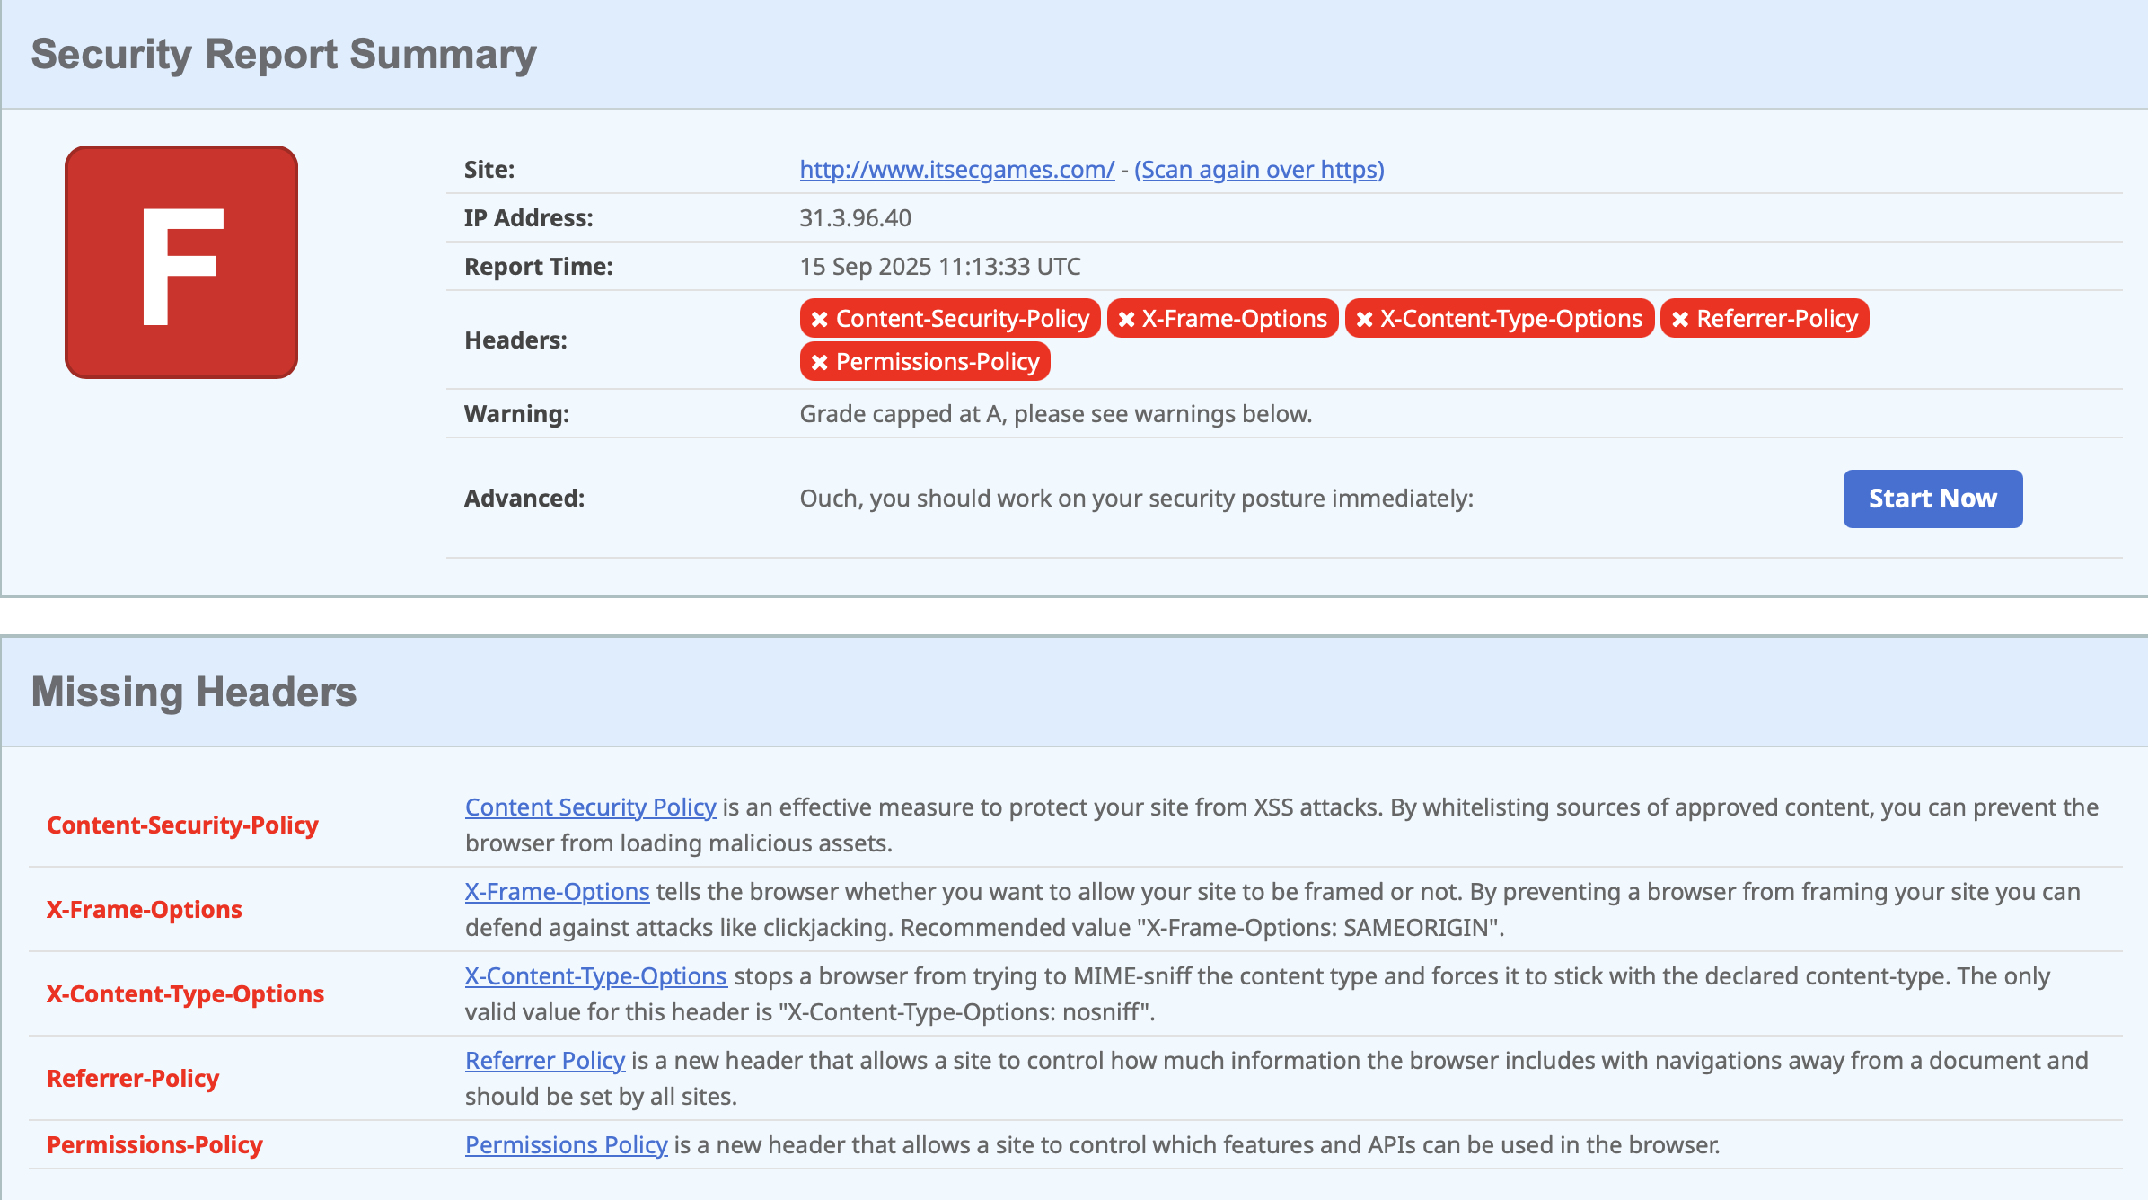

**2.2 SSL/TLS and Certificates (SSL Labs Scan)**

**Certificate Issues:**

* Certificate expired on 22 May 2025.
* Self-signed certificate, not trusted by browsers.
* Hostname mismatch (issued for web.mmebvba.com, not itsecgames.com).
* No Certificate Transparency logs.
* No revocation information (OCSP/CRL).

**Protocol and Cipher Issues:**

* TLS 1.0 and TLS 1.1 enabled (deprecated, insecure).
* TLS 1.2 supported; TLS 1.3 not supported.
* Weak ciphers (AES-CBC, CAMELLIA) allowed.
* No forward secrecy with reference browsers.

**Other SSL/TLS Issues:**

* No HSTS (HTTP Strict Transport Security).
* No OCSP stapling.
* Vulnerable to BEAST attack (TLS 1.0 with AES-CBC).

**Severity:** Critical

**Impact:** Users cannot establish a trusted connection; attackers can exploit weak protocols and ciphers.

**Recommendation:** Deploy a valid CA-signed certificate, disable weak protocols/ciphers, and enable TLS 1.3 with strong cipher suites.

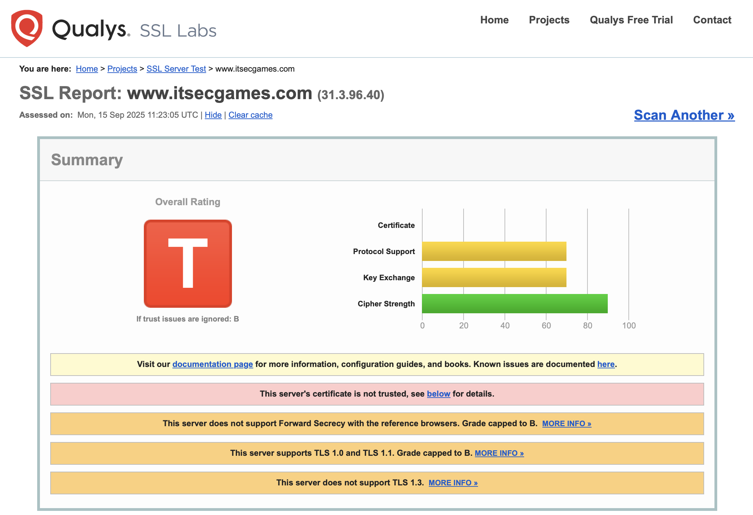

**2.3 DNS and Redirection (Manual Verification)**

**Observations:**

* http://itsecgames.com → responds with HTTP/1.1 200 OK (Apache).
* https://itsecgames.com → redirects to https://mmebvba.com.
* https://mmebvba.com → responds with headers (X-Frame-Options: SAMEORIGIN, X-Content-Type-Options: nosniff) but discloses CMS as **Drupal 7**, which is end-of-life as of January 2025.
* No CAA records found in DNS.

**Severity:** High

**Impact:** Redirection to another domain may confuse users and increase phishing risk; outdated CMS introduces known vulnerabilities.

**Recommendation:** Upgrade CMS to a supported version, add CAA records, and ensure HTTPS is served directly on itsecgames.com if intended for production.

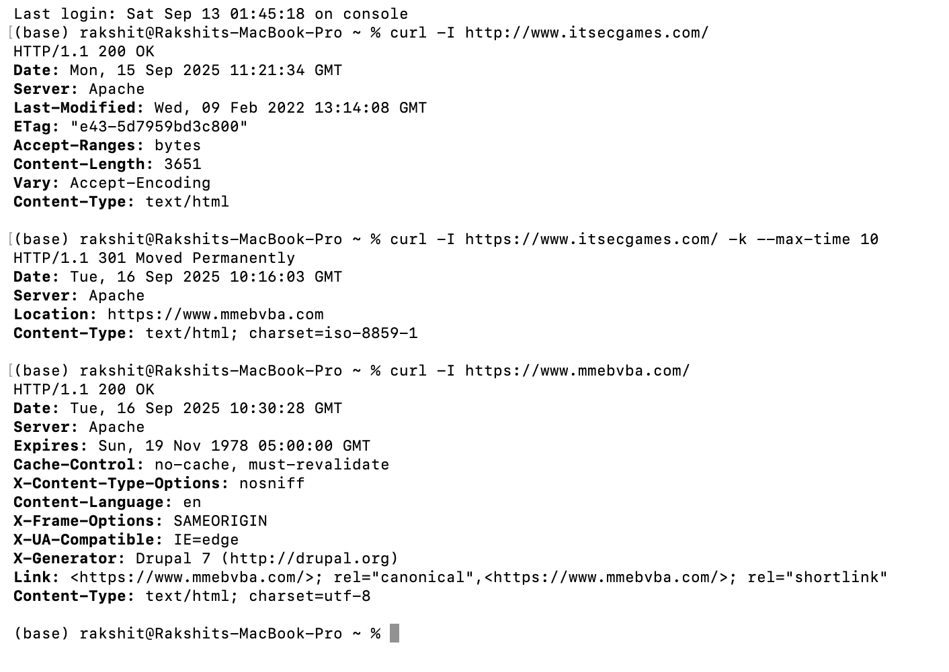

**2.4 Server Banner Disclosure**

**Observations:**

* Server header reveals Apache.

**Severity:** Low

**Impact:** Discloses server software, which attackers may exploit using known vulnerabilities.

**Recommendation:** Hide server version using ServerTokens Prod and ServerSignature Off in Apache configuration.

**3. Risk Analysis**

|  |  |  |
| --- | --- | --- |
| **Category** | **Severity** | **Impact** |
| HTTP only (no HTTPS redirection) | Critical | Unencrypted traffic, MITM attacks |
| Expired, self-signed certificate | Critical | No trust, spoofing possible |
| TLS 1.0/1.1 enabled | Critical | Vulnerable to downgrade and BEAST attacks |
| Outdated CMS (Drupal 7) | High | Known unpatched vulnerabilities |
| Missing security headers | High | XSS, clickjacking, information leakage |
| Weak ciphers enabled | High | Reduced resistance to brute-force |
| No HSTS / OCSP stapling | Medium | Downgrade and revocation-checking issues |
| Server banner disclosure | Low | Information leakage |

**4. Recommendations**

**4.1 SSL/TLS Hardening**

* Deploy a valid CA-signed certificate for itsecgames.com.
* Enable TLS 1.2 and TLS 1.3; disable TLS 1.0 and TLS 1.1.
* Remove weak ciphers; prefer strong ECDHE-based suites.
* Enable Forward Secrecy, HSTS, and OCSP stapling.

**4.2 Security Headers**

* Add the following headers:
  + Content-Security-Policy
  + X-Frame-Options
  + X-Content-Type-Options
  + Referrer-Policy
  + Permissions-Policy

**4.3 DNS and CMS**

* Add CAA records to control certificate issuance.
* Upgrade CMS to a supported version (Drupal 10+).
* Ensure redirect to external domain (mmebvba.com) is intentional and documented.

**4.4 Server Configuration**

* Update Apache to the latest stable version.
* Hide server version information.
* Periodically test with SSL Labs and header-checking tools.

**5. Conclusion**

The assessment of **itsecgames.com** revealed multiple critical security issues, including the absence of HTTPS enforcement, expired and untrusted certificates, insecure TLS protocols, missing headers, and outdated CMS software.

Without immediate remediation, the site remains vulnerable to interception, spoofing, downgrade attacks, and exploitation of known vulnerabilities.

**Final Risk Posture:** Insecure – Immediate remediation required.